Major Research Paper:
The Deconstruction of Media, Social Visibility, and Ability/Disability Myths:
An Analysis of George R.R. Martin's Game of Thrones

Xianglong Lin
45791439
COMU2150: Media and Identity

I declare that I HAVE used generative AI for this assignment,
and I have documented that use according to the requirements set out in the assessment
documentation.

Table of Contents
Introduction 3
Main Body 3
The Role of the Media in the Social Construction of Disability 3
Tyrion Lannister: Subverting the Stereotype of "Disadvantage" 4
Tyrion's Visibility and Challenging Social Stereotypes 4
Peter Dinklage's Representation 4
Tyrion and the Social Model of Disability 4
Bran Stark: The Supercrip Narrative and Redefinition of Ability 5
Potential Risks of the Supercrip Narrative 5
Redefine the Meaning of Ability 5
Jaime Lannister: Acquired Disability and Identity Reconstruction 5
Identity Crisis and Social Expectations 6
Adaptation and Personal Growth 6
Revelation of Social Dynamics 6
Representation Behind the Scenes: The Importance of Authentic Voices 6
Continuation and Challenge of Myths 7
Social Visibility, Media and Disability Activism 7
Conclusion 8
References 9
Appendix 10
Prompt and Response 10
Critical Evaluation 11
Refining and Enhancing the AI-Generated Responses 11
Exclusions Made and the Reasons for Omission 12

Introduction

In the documentary Examined Life, Judith Butler and Sunaura Taylor (2008) explore how visibility in public spaces deconstructs myths about disability in order to break down the binary division between ability and disability. The media plays a critical role in shaping public perceptions of the body, normality, and disability. Its representation of disability directly determines whether disabled people are recognised as part of a "normal" and diverse society or are identified as outliers. This article will analyse the representation of disability in the TV series Game of Thrones (2011-2019), focusing on the characters Tyrion Lannister, Jaime Lannister, and Bran Stark, to explore how the series challenges and perpetuates myths about disability and identity. The article will also refer to academic materials such as Ellis (2015), Haller & Preston (2016), and Cocq & Ljuslinder (2020), to analyse the impact of media discourse on disability, the current status of representation of disabled people behind the scenes, and how this representation affects the identity of disabled people.

Main Body

The Role of the Media in the Social Construction of Disability

The media is not only used to convey information, but also influences the audience's perception of social reality. The portrayal of disability in the media often presents 2 stereotypes: the "supercrip" and the "pitiful victim". The proliferation of these images leads society to view disability as an obstacle to overcome or a weakness worthy of sympathy. Haller and Preston (2016) argue that the portrayal of people with disabilities in the media often places them in an incomplete and different situation, leading to exacerbation of social prejudice that normalises health as a standard, and thus any deviation from this standard should be corrected, overcome, or surpassed.

However, disability is not only a physical limitation, but also a product of social construction. Cocq and Ljuslinder (2020) emphasise the importance of self-expression, indicating that platforms such as social media provide opportunities for people with disabilities to participate in defining and building their own identities to break stereotypes in traditional media.

In Examined Life, Butler and Taylor (2008) propose that increasing the social visibility of disabled groups is the key to deconstructing the concept of "normality". If disabled people are seen and heard in public spaces, society's understanding of abilities can be more diverse and inclusive. Therefore, the performance of the media is not only a reflection of reality, but also a significant influence on the audience's perception of disability and the concepts of "normal" and "abnormal".

Tyrion Lannister: Subverting the Stereotype of "Disadvantage"

Peter Dinklage's portrayal of Tyrion Lannister is one of the most iconic disabled characters in Game of Thrones. As a dwarf, he has long suffered from social and family prejudice. However, he is not a weak or helpless character, but rather a key figure in the story with his wisdom, insight, and complex moral values.

Tyrion's Visibility and Challenging Social Stereotypes

Haller and Preston (2016) suggest that Tyrion's presence as a protagonist and complex character subverts traditional stereotypes of disabled people. He is not only the object of sympathy, but also an active participant in shaping his own destiny. This performance endows the disabled character with the complexity and depth of a healthy character. Tyrion, with his wisdom and resourcefulness, has escaped the label of "dwarf" or "marginalised person" and become a well-rounded and three-dimensional individual.

Haller and Preston (2016) also highlight that when disabled people are represented as capable and empowered, there are positive changes in society’s perception of disability. Tyrion's wisdom, political sensitivity, and sense of humor have made him an important player and influential figure in the power struggle. He is not ultimately characterised as a victim, but instead earns respect through self-struggle and forcefully challenges stereotypes.

Peter Dinklage's Representation

Furthermore, Peter Dinklage himself is a dwarf actor, avoiding the problem of able-bodied actors "playing" disabled roles. Fox and Sandahl (2018) critique that able-bodied actors portraying disabled characters will deepen social misunderstanding and reinforce stereotypes of disability. However, having real disabled actors portray disabled characters will enhance the authenticity of representation and give voice to disabled individuals in the media.

Tyrion and the Social Model of Disability

Tyrion’s story is closely tied to social models of disability. According to the social model, disability is not only determined by an individual's physical condition, but also by society's response to that condition (Ovid Technologies, 1991). In Game of Thrones, Tyrion's experience shows that the difficulties in life mainly stem from social prejudice and discrimination, rather than just his physical condition. This narrative style makes the audience think deeply about the nature of disability and how society marginalises people with disabilities.

Bran Stark: The Supercrip Narrative and Redefinition of Ability

The character development of Bran Stark illustrates the dual challenges faced by individuals with disabilities when dealing with physical limitations and the search for social recognition. In the early days of Game of Thrones, Bran is a lively child, but he was paralysed in an accident and lose the ability to walk. However, in the subsequent plot, he beomes the Three-Eyed Raven with extraordinary prophetic abilities and mental powers.

Potential Risks of the Supercrip Narrative

Bran's character inevitably falls into the trap of the "supercrip" narrative. Schalk (2016) defines it as portraying disabled characters as compensating for physical disabilities through superpowers or achievements. After losing his mobility, Bran relies on his mental abilities to regain a new purpose in life, and it seems to convey that disabled people can only use extraordinary abilities to prove their own value.

Therefore, this narrative may spread a misleading concept that people with disabilities have to prove their value through outstanding abilities or achievements. However, Bran's story also challenges the traditional concept that physical ability equals social ability to a certain extent. Becoming a Three-Eyed Raven, he demonstrates the possibility of changing the world with wisdom and mental strength instead of physical strength, which is consistent with Butler and Taylor’s redefinition of disability as a concept of ability (2008).

Redefine the Meaning of Ability

Bran's experience demonstrates that ability is not limited to physical integrity, but can be complemented by spiritual, emotional, and social contributions. The audience is encouraged to rethink the true meaning of ability and how society defines and evaluates value, with emphasis on the importance of spiritual and emotional contributions, by using the late development of Bran to compensate for the lack of physiological function.

Jaime Lannister: Acquired Disability and Identity Reconstruction

The story of Jaime Lannister provides profound insights into understanding the impact of acquired disabilities on personal identity. As the top swordsman of the Lannister family, his value is mainly manifested in his swordsmanship. However, after losing his right hand in a battle, he not only faces the plight of physical disability, but also has to rebuild his image.

Identity Crisis and Social Expectations

The loss of his right hand not only deprives Jaime of his livelihood, but also forces him to reassess his social status and value in deep despair. He even begins to doubt whether life has lost all meaning, as his identity is inextricably linked to swordsmanship. As Ovid Technologies (1991) mentions, disability is not only a simple physical condition, but also a social response and interpretation of this condition. Therefore, Jaime has to face the re-evaluation of his abilities by society and the subsequent social exclusion and self-identity crisis.

Adaptation and Personal Growth

In the subsequent plot, Jaime begins to adapt to his new lifestyle, and his interaction with Brienne teaches him how to continue to survive and fight after losing his right hand. The story of reconstruction proves that disability is not synonymous with incompetence, and individuals can grow and reshape their values through adaptive and reconstructing experiences.

Jaime's transformation echoes Butler and Taylor's discussion on redefining ability (2008). Instead, he has cultivated a humility and empathy that he did not have before in adapting to his new life, which has enriched and three-dimensionalised his image, and disability has thus become a turning point in his self-exploration and growth.

Revelation of Social Dynamics

Jaime's story also reveals the dynamic changes in social interaction caused by disability. Without his right hand, his abilities in certain situations are underestimated and no longer considered a threat, allowing him to gain new freedom in specific environments. Cocq and Ljuslinder (2020) also claim that the identity of disabled individuals is composed of multiple factors. Jaime shows how disabled people can regain their self-esteem under social expectations and win respect and recognition in different ways.

Representation Behind the Scenes: The Importance of Authentic Voices

Although Game of Thrones presents many important disabled characters on screen, the participation of representatives of people with disabilities in the behind-the-scenes production is still limited. Apart from Peter Dinklage, there are almost no other disabled screenwriters, directors, or producers in the series. Cocq and Ljuslinder (2020) emphasise that ensuring the participation of people with disabilities in key creative roles is crucial to achieving true representation.

The absence of disability elements may have limited the breadth, depth, and authenticity of the disability narratives contained in the series to some extent. As Haller and Preston (2016) point out, true representation should not only appear on the screen, but also be constructed behind the scenes. Therefore, the participation of more disabled creators can enrich the portrayal of disability in the media and further avoid stereotypes.

Continuation and Challenge of Myths

Although Game of Thrones challenges the myth of disability, it inevitably perpetuates certain stereotypes:
- Stereotypes of Supercrips and Magical Cures: Bran Stark's magical transformation fits the “supercrip” stereotype, implying that disability must be restored or compensated for through special abilities (Schalk, 2016).
- Challenging the Stereotype of "Disadvantage": Tyrion Lannister's character breaks the myth that people with disabilities are inferior, reflecting that disability is part of human diversity (Ellis, 2015).
- Reconstruction and Adaptation of Identity: Jaime Lannister's adaptation stage after losing his right hand illustrates the potential of individuals to regain their self-identity after disability.

The shaping of these roles reflects the complex relationship between society's expectations for disability and individual experiences. As described by Ovid Technologies (1991), disability is a social barrier that limits an individual's participation and inclusiveness, rather than a simple physical defect.

Social Visibility, Media and Disability Activism

The media plays a pivotal role in enhancing the social visibility of individuals with disabilities. Butler and Taylor (2008) state that visibility is crucial to challenging myths and changing social perceptions. Game of Thrones uses diverse disabled characters to present the visibility of the disabled community, but also reveals the limitations and constraints of mainstream media in completely breaking away from the narrative of soundness.

Consistent with the disability activism discussed in the academic materials used, the media's presentation of disability should go beyond the individual level and focus on broader systemic issues. Enhancing the participation of individuals with disabilities in the creative and narrative processes can help promote a more comprehensive understanding of disability as a part of human diversity.

Conclusion

The media plays an important role in shaping society's perception of the body, abilities, and normality. Game of Thrones has portrayed disability in multiple dimensions through the portrayal of characters such as Tyrion Lannister, challenging negative stereotypes while also perpetuating these myths in certain areas. Tyrion's role breaks the negative stereotype of disability, highlighting the complex meaning and value of the existence of individuals with disabilities. Although Bran's story is caught in the supercrip narrative, which implies the traditional concept that disability can only be compensated for,

Jaime’s identity reconstruction shows the individual's growth and adaptability after disability.
This article analyses these roles in depth to interpret the complexity and diversity of disability discourse in the media. The media should not only present diverse disabled characters on screen, but also increase the participation of disabled people behind the scenes to ensure the authenticity and accuracy of disability stories. As Butler and Taylor (2008) argue, the enhancement of visibility is the key to deconstructing the myth of disability. The continuous and critical participation and promotion of equal participation of people with disabilities by the media can crucially promote social understanding and inclusiveness of disability.

References
Butler, J., & Taylor, S. (2008). Examined Life [Film segment]. In A. Taylor (Director), Examined
Life [Film]. Zeitgeist Films. Available at https://www.kanopy.com/en/uq/video/178180
Cocq, C., & Ljuslinder, K. (2020). Self-representations on social media: Reproducing and
challenging discourses on disability. Alter, 14(2), 71–84. https://doi.org/10.1016/j.alter.2020.02.001
Ellis, K. (2015). *Disability and popular culture: Focusing passion, creating community and
expressing defiance*. Taylor & Francis Group.s
Fox, A. M., & Sandahl, C. (2018). Beyond "Cripping Up": An introduction. Journal of Literary &
Cultural Disability Studies, 12(2), 121–127. https://doi.org/10.3828/jlcds.2018.9
Haller, B., & Preston, J. (2016). Confirming normalcy: 'Inspiration porn' and the construction of
the disabled subject? In K. Ellis & M. Kent (Eds.), Disability and social media: Global perspectives (pp. 41–56). Routledge. https://doi.org/10.4324/9781315577357
Ovid Technologies. (1991). The politics of disablement (M. Oliver, H. M. Bochel, Eds.).
MacMillan. https://doi.org/10.1097/00004356-199106000-00012
Schalk, S. (2016). Reevaluating the supercrip. Journal of Literary & Cultural Disability Studies,
10(1), 71-86. https://doi.org/10.3828/jlcds.2016.5

Appendix

Prompt and Response

- Prompt 1: Provide an analysis of how the character Tyrion Lannister from Game of Thrones challenges the stereotypical portrayal of disability in media and how this aligns with the social model of disability.

Response 1:
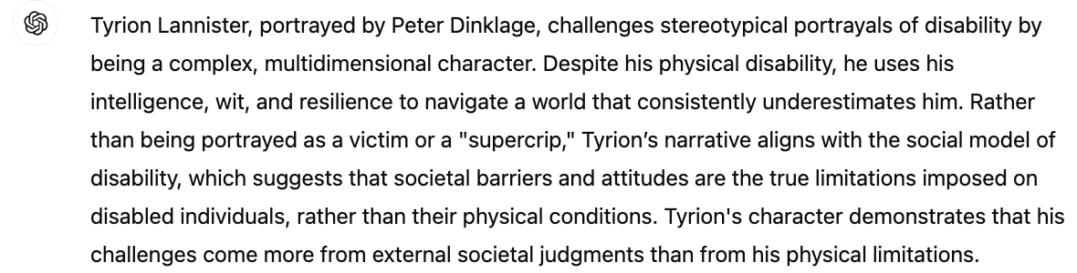

- Prompt 2: Discuss how Bran Stark’s narrative in Game of Thrones reflects the "supercrip" stereotype and its potential impact on the perception of disability.

Response 2: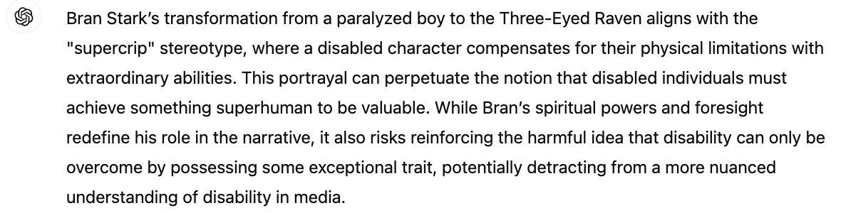

- Prompt 3: Explain how Jaime Lannister’s character development in Game of Thrones after losing his hand aligns with the concept of identity reconstruction following disability.

Response 3: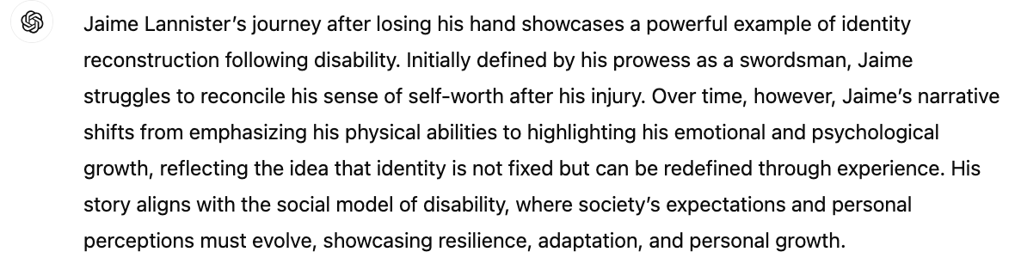

Critical Evaluation

AI accurately grasped the complexity of Tyrion's character and the challenges he poses to disability stereotypes, but lacked a deep exploration of the impact of social attitudes on him in the show. I expanded on my view of AI, emphasising Tyrion's interactions with other characters, to further reveal how the power relations in society and family deepen his predicament. In addition, I cited academic sources to more fully support the concept of the social model of disability.

While AI had portrayed the "supercrip" stereotype of Bran Stark, it also lacked a deep analysis of this phenomenon. I critically thought about this narrative, focusing on the discussion of how this stereotype sets inappropriate expectations for disabled people, while marginalising those who have not yet demonstrated superhuman abilities. Therefore, I advocated for a more balanced portrayal of disabilities in the media, avoiding solely relying on special abilities to justify the value of the character.

AI's analysis of Jaime Lannister's identity reconstruction remained superficial, without further discussion of his emotional growth experiences. Therefore, I expanded this part on the framework of the AI content retained, depicting how Jaime gradually accepts his own changes during the interactions with Brienne and is able to rebuild himself on an emotional level. This not only deepens the discussion on identity reshaping, but also reveals the impact of disability on interpersonal relationships.

Refining and Enhancing the AI-Generated Responses

When reviewing the responses generated by AI, although basic ideas and reasonable frameworks were provided, the breadth, depth, and specificity required for academic analysis were missing. For example, in Response 1, AI correctly outlined Tyrion's challenges with disability stereotypes, but the in-depth exploration of how social and family dynamics exacerbate these challenges was neglected. I incorporated specific episodes in this section to demonstrate how social attitudes can impose deeper restrictions on him.
In Response 2, AI mentioned the fact that Bran Stark falls into the category of "supercrip", but meanwhile I believed it was both necessary and appropriate to further discuss the broader impact of this stereotype in popular culture. Therefore, I conducted a deep analysis of the cultural consequences of the stereotype of "supercrip", emphasising the importance of presenting a balanced portrayal of disabled characters, and suggesting that while paying attention to the superpowers of characters, it is more important to show the real challenges in daily life.

In Response 3, the AI's reconstruction of Jaime Lannister's identity lacked emotional depth and in-depth discussion of his psychological and emotional transformation. I discussed Jaime's gradual adaptation to life after his disability by adding his interactions with other characters, which sharply contrast with his previous status as a top swordsman. Such improvement is not only the enrichment of emotional depiction, but also the demonstration and strengthening of how disability can promote personal growth and transformation.

Exclusions Made and the Reasons for Omission

In most cases, the responses from AI were too vague or repetitive, this is why I chose not to adopt them. For instance, in Response 2, AI redefined Bran Stark's mental abilities without further meaningful analysis of his character. Therefore, I chose to ignore this vague assertion and focus on in-depth criticism of the stereotype of "supercrip" and analyse its impact on disability cognition.

Similarly, for Response 1, AI mentioned that Tyrion challenges the stereotype of disability, but did not provide specific examples of the plot. So I deleted this general statement and replaced it with a specific analysis of Tyrion's performance in important episodes in Game of Thrones, showing how Tyrion survives under the dual pressures of disability and social prejudice, making the argument more powerful and detailed.

